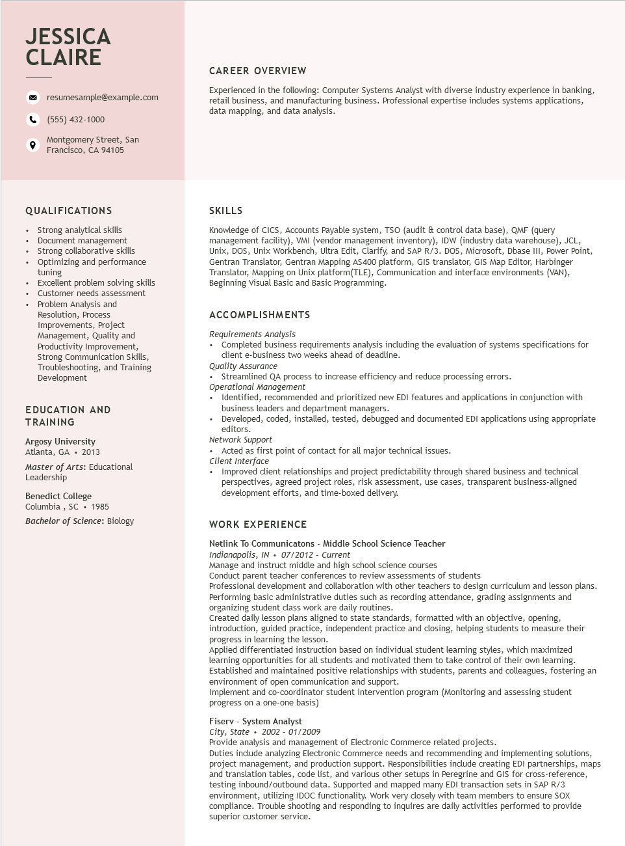
JESSICA CLAIRE
resumesample@example.com
(555) 432-1000
Montgomery Street, San Francisco, CA 94105
CAREER OVERVIEW
Experienced in the following: Computer Systems Analyst with diverse industry experience in banking, retail business, and manufacturing business. Professional expertise includes systems applications, data mapping, and data analysis.
QUALIFICATIONS
•
Strong analytical skills
Document management
•
·
Strong collaborative skills
•
•
Optimizing and performance tuning
Excellent problem solving skills
Customer needs assessment
Problem Analysis and
Resolution, Process Improvements, Project Management, Quality and Productivity Improvement, Strong Communication Skills, Troubleshooting, and Training Development
EDUCATION AND TRAINING
Argosy University
2013
Atlanta, GA
Master of Arts: Educational Leadership
Benedict College Columbia, SC. 1985
Bachelor of Science: Biology
SKILLS
Knowledge of CICS, Accounts Payable system, TSO (audit & control data base), QMF (query management facility), VMI (vendor management inventory), IDW (industry data warehouse), JCL, Unix, DOS, Unix Workbench, Ultra Edit, Clarify, and SAP R/3. DOS, Microsoft, Dbase III, Power Point, Gentran Translator, Gentran Mapping AS400 platform, GIS translator, GIS Map Editor, Harbinger Translator, Mapping on Unix platform(TLE), Communication and interface environments (VAN), Beginning Visual Basic and Basic Programming.
ACCOMPLISHMENTS
Requirements Analysis
• Completed business requirements analysis including the evaluation of systems specifications for client e-business two weeks ahead of deadline.
Quality Assurance
• Streamlined QA process to increase efficiency and reduce processing errors.
Operational Management
• Identified, recommended and prioritized new EDI features and applications in conjunction with business leaders and department managers.
• Developed, coded, installed, tested, debugged and documented EDI applications using appropriate editors.
Network Support
• Acted as first point of contact for all major technical issues.
Client Interface
• Improved client relationships and project predictability through shared business and technical perspectives, agreed project roles, risk assessment, use cases, transparent business-aligned development efforts, and time-boxed delivery.
WORK EXPERIENCE
Netlink To Communicatons - Middle School Science Teacher
Indianapolis, IN⚫ 07/2012 - Current
Manage and instruct middle and high school science courses
Conduct parent teacher conferences to review assessments of students
Professional development and collaboration with other teachers to design curriculum and lesson plans. Performing basic administrative duties such as recording attendance, grading assignments and organizing student class work are daily routines.
Created daily lesson plans aligned to state standards, formatted with an objective, opening, introduction, guided practice, independent practice and closing, helping students to measure their progress in learning the lesson.
Applied differentiated instruction based on individual student learning styles, which maximized learning opportunities for all students and motivated them to take control of their own learning. Established and maintained positive relationships with students, parents and colleagues, fostering an environment of open communication and support.
Implement and co-coordinator student intervention program (Monitoring and assessing student progress on a one-one basis)
Fiserv - System Analyst
City, State 2002 - 01/2009
Provide analysis and management of Electronic Commerce related projects.
Duties include analyzing Electronic Commerce needs and recommending and implementing solutions, project management, and production support. Responsibilities include creating EDI partnerships, maps and translation tables, code list, and various other setups in Peregrine and GIS for cross-reference, testing inbound/outbound data. Supported and mapped many EDI transaction sets in SAP R/3 environment, utilizing IDOC functionality. Work very closely with team members to ensure SOX compliance. Trouble shooting and responding to inquires are daily activities performed to provide superior customer service.

